
RECORD OF EXPERIMENTS
Register Number: 231801093
Academic Year 2025 – 2026
List of Experiments
- Private Cloud using OpenStack
- PaaS in Public Cloud Using Render
- Setting Up Hybrid Cloud Connectivity Using Cisco Packet Tracer
- Virtual Private Server (VPS) Provisioning and Configuration
- Cloud Backup and Migration using Google Drive
- CDN Service Selection and Configuration

Ex: 6 | CDN Service Selection and Configuration
Date:21/08/2026

Aim
To select a Content Delivery Network (CDN) provider, deploy a simple web application using Cloudflare, access it through Cloudflare's edge network, and verify the HTTP response and Cloudflare-specific headers using browser Developer Tools.

What is a CDN, and Why Cloudflare?
A Content Delivery Network (CDN) is a distributed network of edge servers that deliver web content from locations closer to the user, reducing latency compared to routing every request to a single distant origin server. Among the providers considered — Cloudflare, Amazon CloudFront, and Akamai — Cloudflare was selected because it combines CDN, DNS, security, and edge-computing (Workers) capabilities and was the most straightforward option for this practical experiment.

Procedure

Part A – Deploying a Worker on Cloudflare
- Sign in to the Cloudflare dashboard (dash.cloudflare.com). No changes to DNS or nameserver settings were required, since only a Worker was needed.
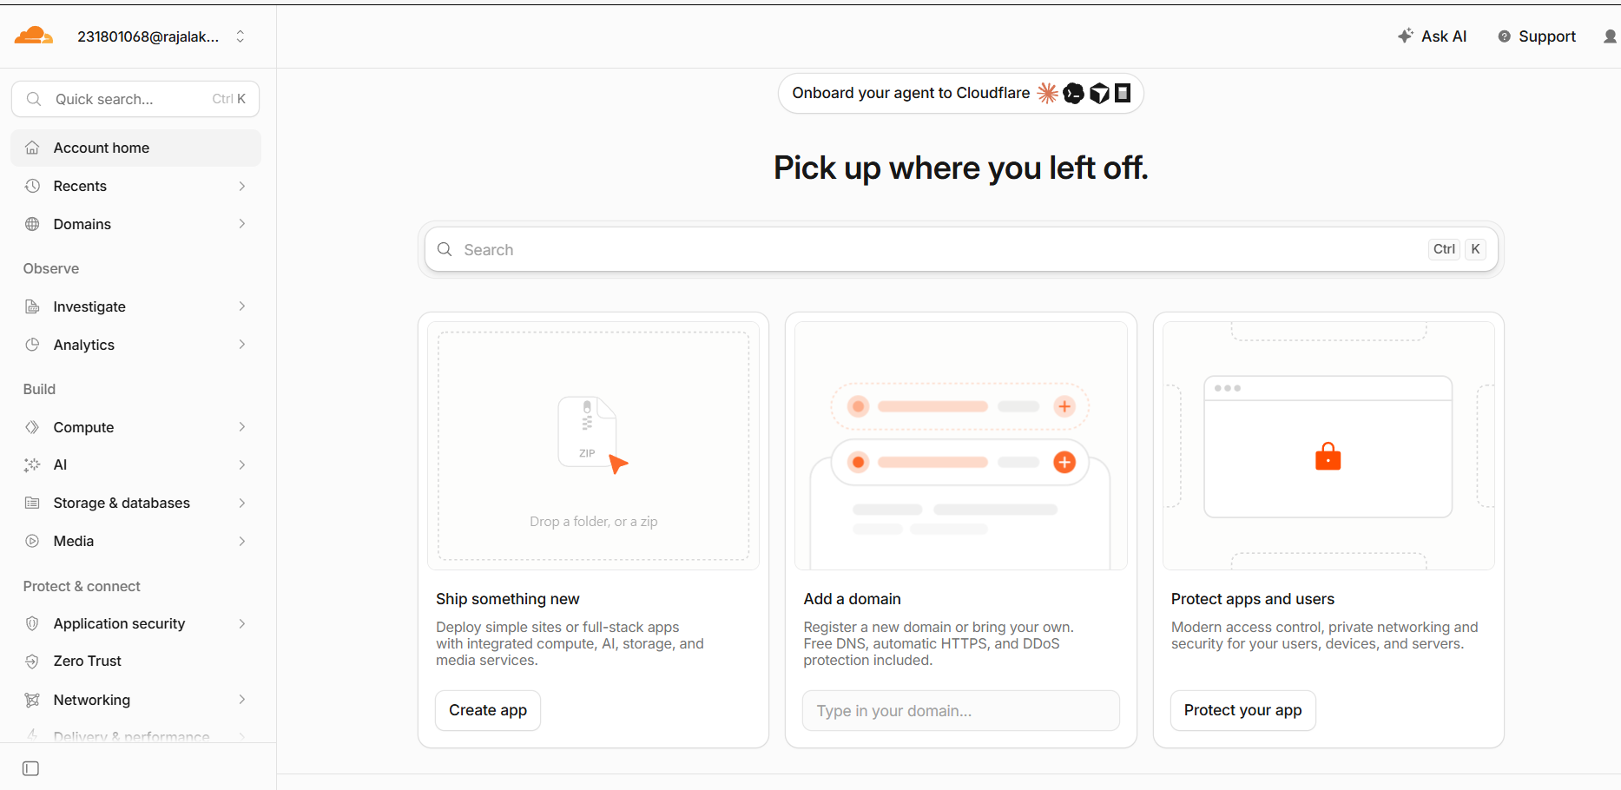
Figure 6.1: Cloudflare dashboard after logging in.

- Choose to create a new Worker and select a deployment method.

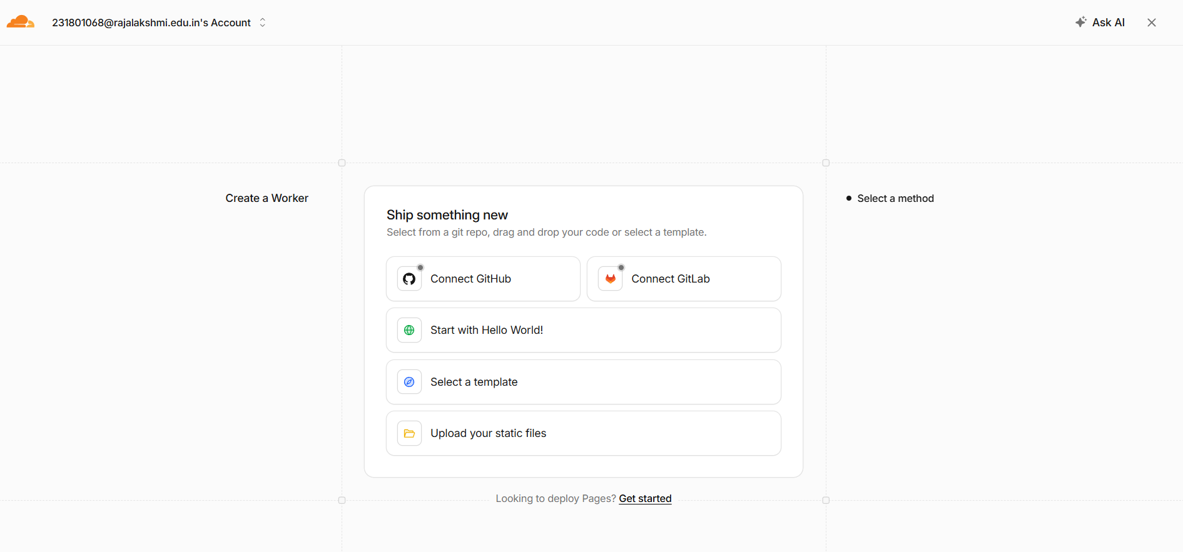
Figure 6.2: Available methods for creating a new Worker.

- Select "Start with Hello World!", the simplest option, which does not require connecting a GitHub or GitLab repository. Cloudflare auto-generates a Worker name and a starter script that returns the text "Hello World!".
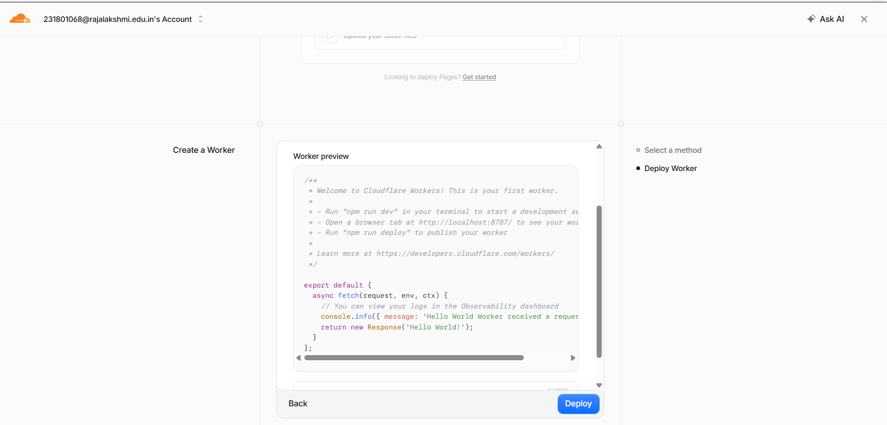
Figure 6.3: Worker preview showing the default Hello World script before deployment.

- Click Deploy. Cloudflare provisions a public address for the application ending in workers.dev.

Part B – Testing the Deployed Application
- Click Visit to open the Worker URL in a new tab and confirm that it displays "Hello World!".

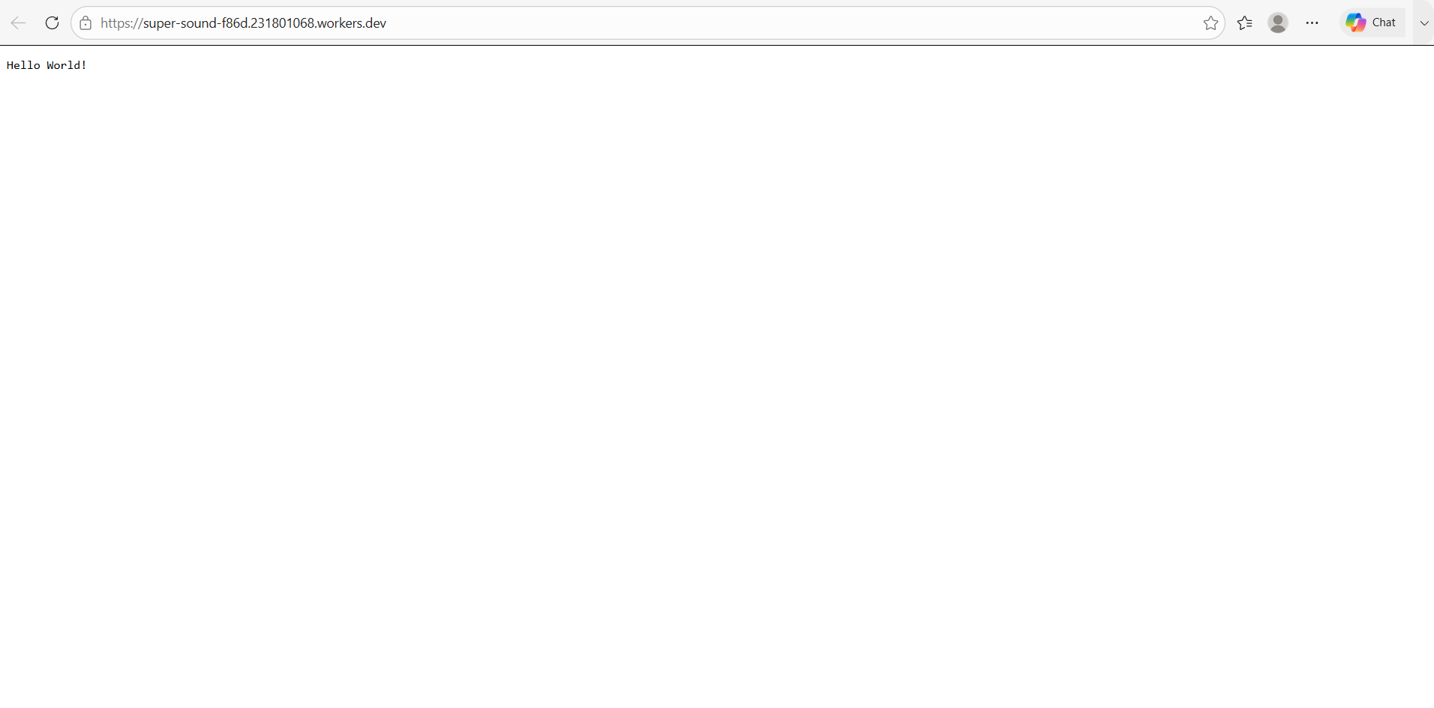
Figure 6.4: The deployed Worker responding with "Hello World!" in the browser.
- Return to the Cloudflare dashboard's Metrics panel and confirm that Invocations increased after visiting the URL, showing that a real request reached the Worker.

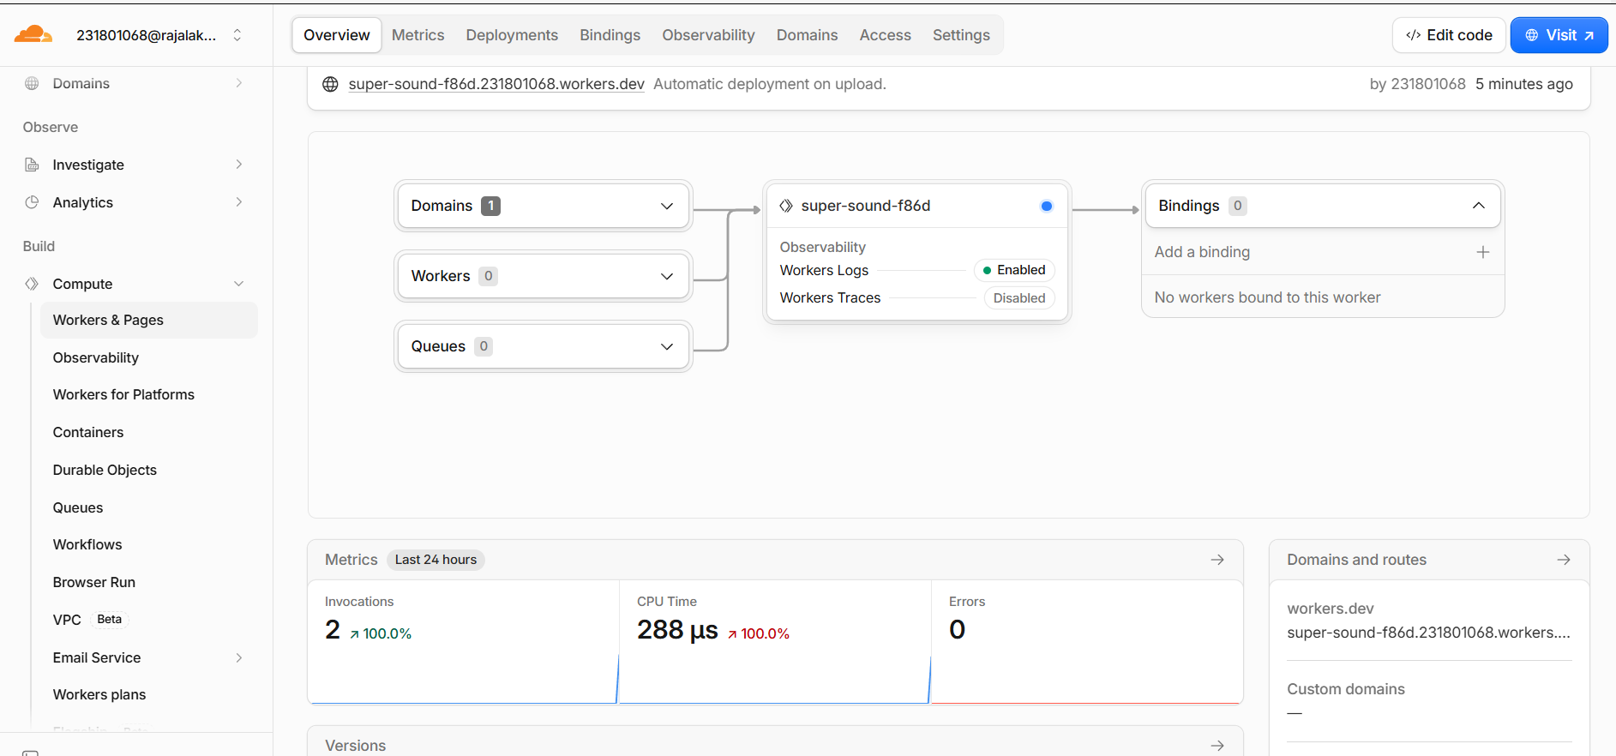
Figure 6.5: Dashboard metrics showing Invocations increased after visiting the Worker URL.

- Open "Edit code" and replace the default response with a small HTML page describing the CDN experiment, then redeploy.

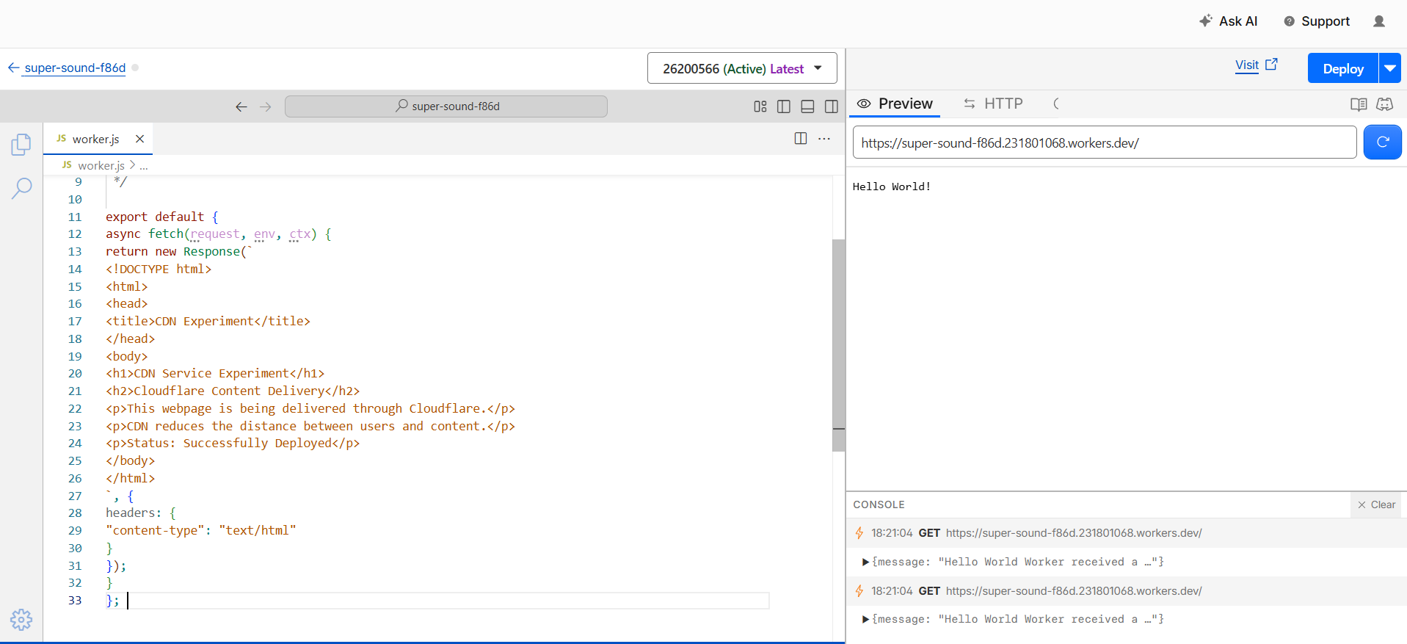
Figure 6.6: Cloudflare's code editor with the updated CDN demonstration page.

- Visit the Worker URL again to confirm the updated page is served.
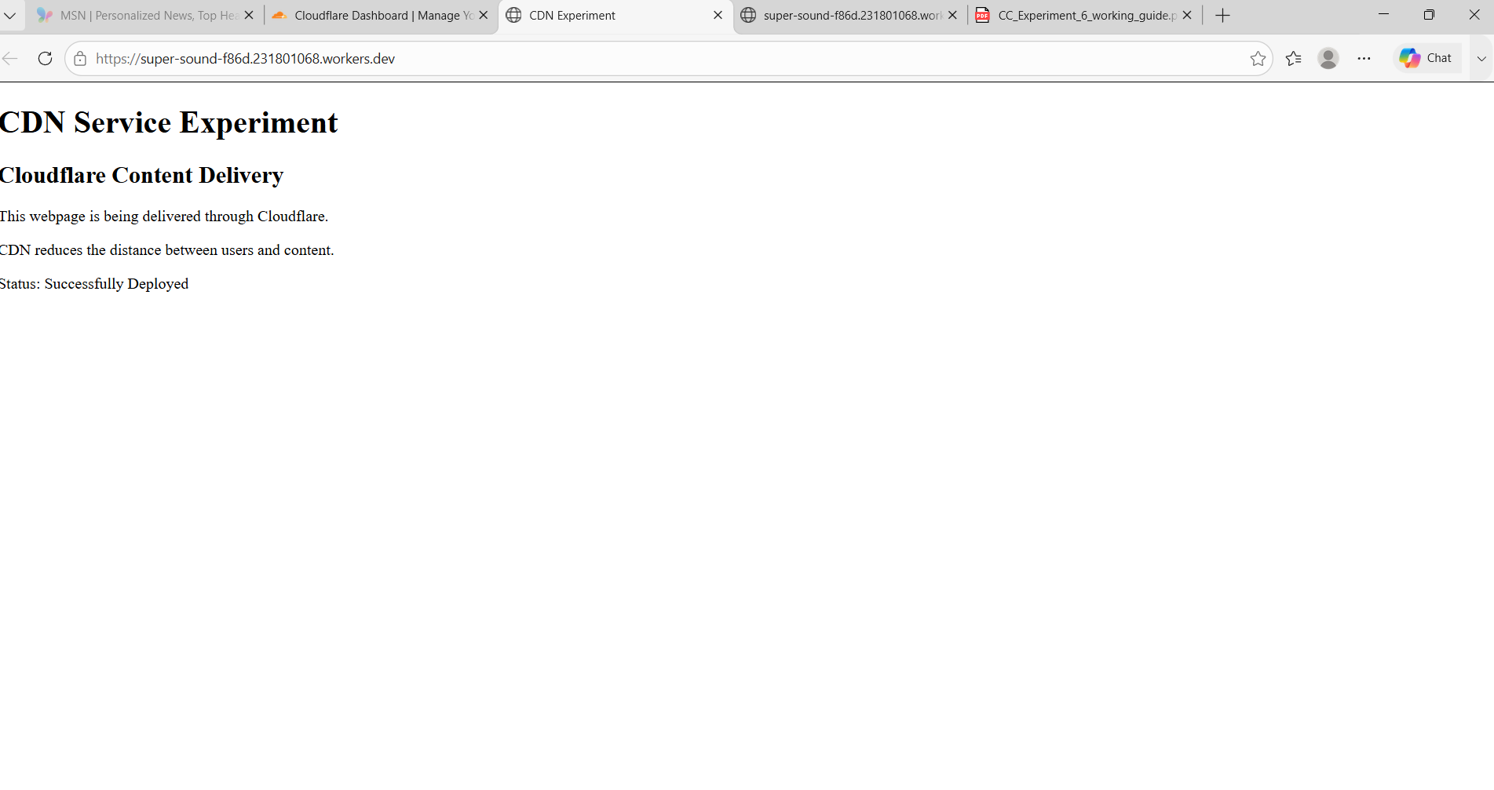
Figure 6.7: The updated CDN demonstration page served from the Worker's public URL.

Part C – Verifying Cloudflare Response Headers
- With the demonstration page open, press F12 to open Developer Tools, select the Network tab, refresh the page (Ctrl+R), and select the request for the workers.dev URL.

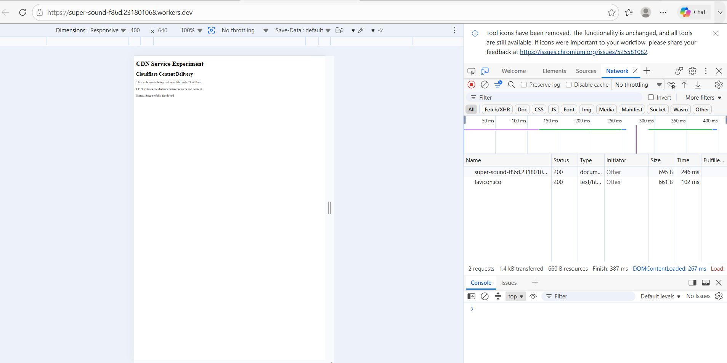
Figure 6.8: Network panel showing the page's requests, both returning status 200.
- Open the Headers tab of the selected request to inspect the response details.

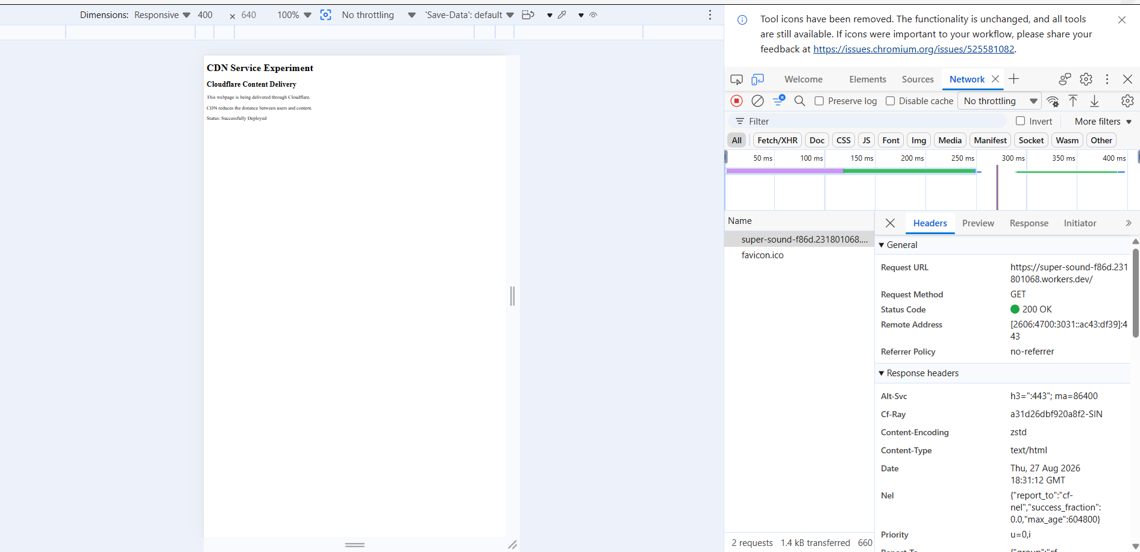
Figure 6.9: Request and response headers viewed in DevTools.
- Confirm Request Method: GET, Status Code: 200 OK, Content-Type: text/html, and the presence of the Cloudflare-specific Cf-Ray header, which verifies the response was served through Cloudflare's edge network.

Conclusion
A Cloudflare-based edge content delivery experiment was successfully implemented. A Worker was deployed and accessed through a public workers.dev URL, the browser received the page with HTTP status 200 OK, and the response headers included Cloudflare-specific information (Cf-Ray), confirming that the content was served through Cloudflare's global CDN.

